Lab 11: Human Evolution

# Part 1: Exercise 21

For this part of the exercise, you will complete part of Exercise 21 in your textbook.

**Question 1**

Review Figure 21.2 in your lab manual, noting the main characteristics of skull morphology.

**Question 2**

Review the six drawings of Figure 21.3, copied below. Write down a few notes on the differences in the skulls using the terminology from Figure 21.2

**Question 3**

On the figure here, label the skulls 1-6 per the directions in the lab manual.

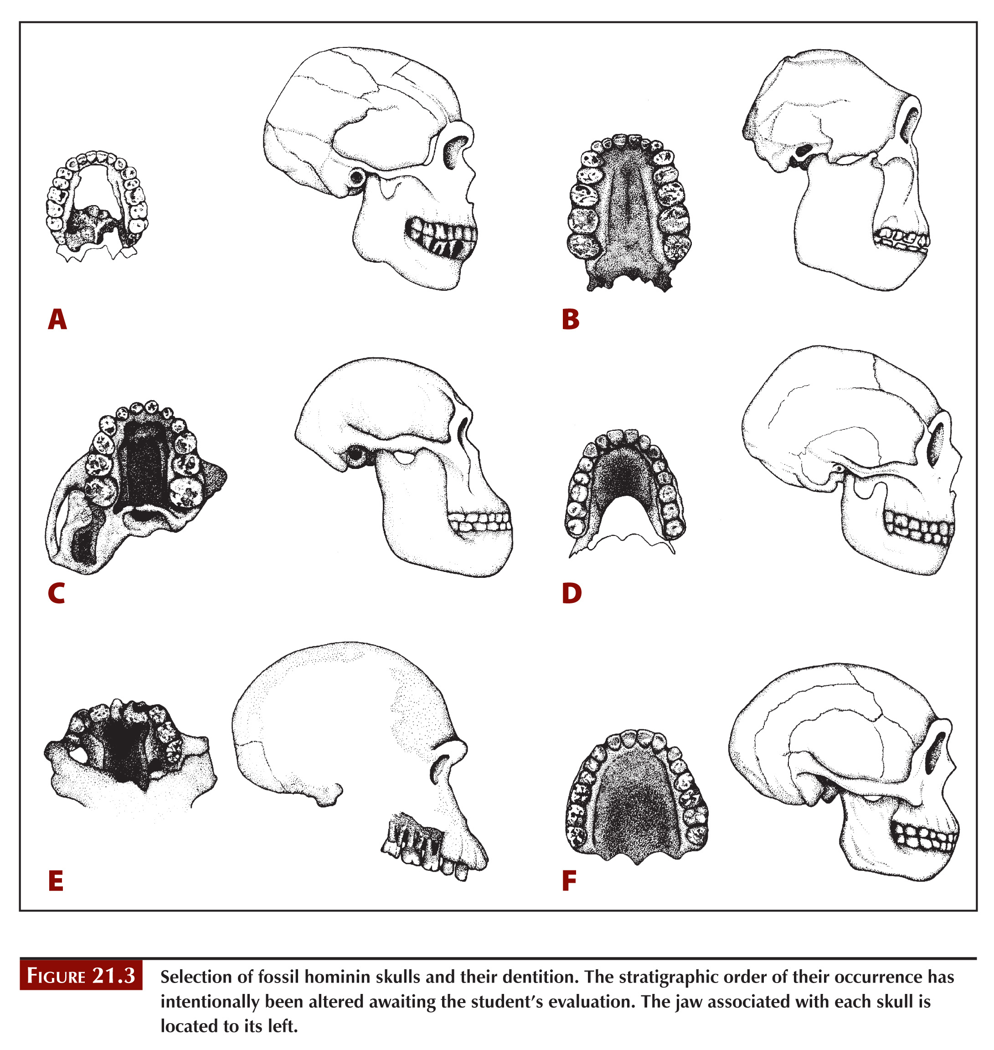

**Question 4: SKIP this question. We will explore this in the next part of this lab.**

# Part 2: 3d Models

This lab is intended for you to recognize some of the anatomical differences expressed in the crania of the hominin clade, and to understand patterns in their evolution over time. We will use 3-D models of various crania (i.e., skulls without mandibles) that are available online. A link to the various models is embedded in the species name, so you should be able to go directly to the proper cranium by clicking on the species. You’ll be able to manipulate the models to look at various features. In addition, you will need to look up a typical cranial capacity for each species. There are two parts to the lab. The first is a comparison of modern hominins and the second is a comparison of fossil hominins and their variation over time. There are also some questions at the end.

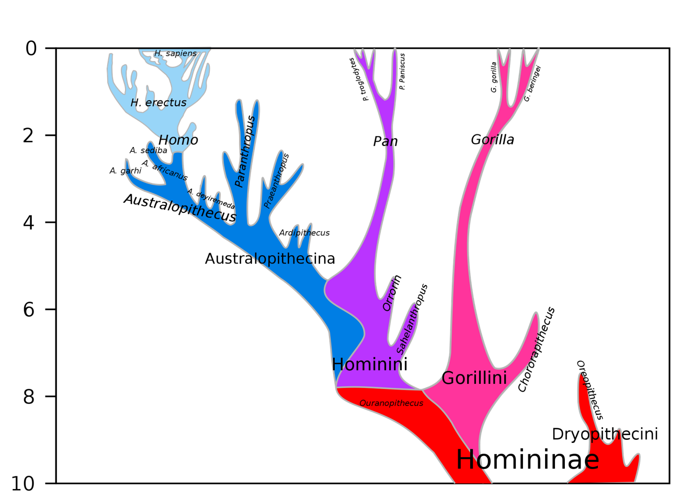

**Figure 1** shows a schematic phylogeny of the hominins. The Homininae includes the Gorillini and the Hominini, which in turn includes *Pan* (chimpanzees & bonobos) and a branch leading to modern humans through the *Australopithecus* and *Homo*. Note the ‘dead end’ branch representing *Paranthropus*, an extinct hominin. You can also see the interconnectedness of modern *Homo sapiens*, blended with Neanderthals and Denisovans. (*Source: Dbachmann; Wikimedia commons*)

# Exercise - Cranial features

*In the tables on the next pages you are asked to describe a variety of features on the crania. We’ll make it simple by assigning a value of 1-3 to most of the features.*

* **Cranial capacity:** Look up (from web resources) the volume of the cranium in cubic centimeters (cc)—this is the part that holds the brain.
* **Dental arcade:** This is the arch of the teeth. Since we’re looking at only the crania, we’ll focus on the maxillary arcade (the top teeth). Are the teeth like a U, with parallel sides and a flattish front, or are they more like a V, with the sides converging towards each other and a pointier front? (*This can be pretty subtle; modern humans are considered a V.*) U=1, in-between = 2, V = 3.
* **Size of teeth:** How large are the teeth relative to the cranium? Focus especially on the molars and look from the bottom. Are they large and robust, indicating a coarse diet such as nuts and seeds that need a lot of grinding, or are the smaller and more gracile, indicating an easier-to-chew diet? Small=1, in-between =2, Large=3
* **Size of canines:** How much do the canines stick out relative to the other teeth, and how pointy are they? Where applicable, we’re looking at male crania in today’s lab to allow you to see the canines, since males tend to have larger canines for fighting. If you’re interested, you can browse different fossils online and look at sexual dimorphism—the tendency for males and females to be different. Small=1, in-between =2, Large=3.
* **Forehead angle:** Does the cranium slope backwards from the top of the eye sockets, or does it go straight up in a forehead? Near-horizontal=1, near 45° = 2; near vertical = 3.
* **Facial angle:** How much does the face stick out, especially below the eyes? Is it prognathous, where the lower face juts out in front of the eyes, or orthognathous, where the face is vertical? Prognathous=1, in-between=2, Orthognathous=3.
* **Brow ridge:** This refers to a bony ridge over the top of the eye sockets. Is it large and protruding, or small? Small=1, in-between =2, Large=3.
* **Sagittal keel or crest:** The sagittal crest is a bony ridge that runs down the top of the skull, and is an attachment point for chewing muscles. Strong chewers tend to have a sagittal crest as well as a thick mandible to withstand the biting force. You can feel the sagittal crest if you pet a dog or cat on the head. A sagittal keel is more of a gentle ridge running down the top of the head, kind of like the bottom of a boat, and does not serve as an attachment point for muscles in the same way. Look at the cranium straight in the face to best see if it is pointy or round on top. Smooth=1, moderate keel=2, high crest=3.

## **Modern hominins**

**The links you need for this activity can be found in the Lab 11 assignment of our course Brightspace site. Go to Brightspace > Content > Week 15 > Lab 11 to access the links.**

|  |  |  |  |  |  |  |  |  |
| --- | --- | --- | --- | --- | --- | --- | --- | --- |
| **Species** | **Cranial capacity** | **Dental arcade** | **Size of teeth** | **Size of canines** | **Forehead angle** | **Facial angle** | **Brow ridge** | **Sagittal keel/crest** |
|  | *(cc)* | *U to V shape* | *Small to large* | *Small to large* | *Low to high* | *Low to high* | *Small to large* | *Small to large* |
| [***Homo sapiens***](https://sketchfab.com/3d-models/human-skull-5af164b073ac4523890d9ac699fa198b)(human) |  |  |  |  |  |  |  |  |
| [***Pan troglodytes***](https://sketchfab.com/3d-models/pan-troglodytes-skull-0289cccc2ecc4158b653bc80ba5ccd95)  (chimpanzee) |  |  |  |  |  |  |  |  |
| [***Gorilla gorilla***](https://sketchfab.com/3d-models/gorilla-gorilla-gorilla-c2c61bfa889f4147af360bd381856993)  (gorilla) |  |  |  |  |  |  |  |  |

## **Fossil hominins**

**The links you need for this activity can be found in the Lab 11 assignment of our course Brightspace site. Go to Brightspace > Content > Week 15 > Lab 11 to access the links.**

|  |  |  |  |  |  |  |  |  |  |
| --- | --- | --- | --- | --- | --- | --- | --- | --- | --- |
| **Species** | **Fossil Age** | **Cranial capacity** | **Dental arcade** | **Size of teeth** | **Size of canines** | **Forehead angle** | **Facial angle** | **Brow ridge** | **Sagittal keel/crest** |
|  | *(My)* | *(cc)* | *U to V shape* | *Small to large* | *Small to large* | *Low to high* | *Low to high* | *Small to large* | *Small to large* |
| [***Sahelanthropus tchadensis***](https://3d.si.edu/object/3d/sahelanthropus-tchadensis-cranium:9730a62f-a649-44fb-8494-aa7c9b6eb1f8) | 7 |  |  |  |  |  |  |  |  |
| [***Ardipithecus ramidus***](https://sketchfab.com/3d-models/ardipithecus-ramidus-25011rp96-1-cranium-680c9f5e43f448369430c53d9c068a12) | 4.4 |  |  |  |  |  |  |  |  |
| [***Australopithecus africanus***](https://sketchfab.com/3d-models/australopithecus-africanus-cranium-b5eba17e494d4febb99c31b18756d181) | 3.5 |  |  |  |  |  |  |  |  |
| [***Paranthropus boisei***](https://sketchfab.com/3d-models/zinj-7987b7a8fa67436a8e1aa07b18bdf65b) | 1.8 |  |  |  |  |  |  |  |  |
| [***Homo habilis***](https://sketchfab.com/3d-models/homo-habilis-da48b81b063c47eaa99116a28995a57f) | 1.9 |  |  |  |  |  |  |  |  |
| [***Homo erectus***](https://sketchfab.com/3d-models/homo-erectus-cranium-sinanthropus-982c7d8530e14ba99ae0f918262d26e2) | 0.8 |  |  |  |  |  |  |  |  |
| [***Homo heidelbergensis***](https://sketchfab.com/3d-models/homo-heidelbergensis-cranium-atapuerca-5-9d488a2dfafe426a91b0d09ae07e119a) | 0.43 |  |  |  |  |  |  |  |  |
| [***Homo neanderthalensis***](https://sketchfab.com/3d-models/homo-neanderthalensis-1979rp15-1-cranium-74a73a5f94914567920481e4fcac14c5) | 0.06 |  |  |  |  |  |  |  |  |
| [***Homo sapiens***](https://sketchfab.com/3d-models/homo-sapiens-hotu-cave-1979rp28-1-cranium-dd181f777a444811a78c7d35b9736648) | 0.01 |  |  |  |  |  |  |  |  |

**Question 1:** Using the 8 features that you measured, how does Homo sapiens differ from other hominins?

**Question 2.** *Paranthropus* (aka robust Australopithecus) is an extinct branch on the human phylogenetic tree, but it was present at the same time as early *Homo*. Using the information you collected, describe how early *Homo* and *Paranthropus* differed, and what this might tell you about their diet.

**Question 3:** Describe trends that you see in each of the 8 features over time. Some of the features may trend systematically, but others may come and go. Comment on which of the features change gradually *versus* suddenly, and any implications for human evolution. Do you notice that Paranthropus deviates from any of the trends as an evolutionary lineage that went extinct?

**Question 4:** Based on your observations, what may the common ancestor of the hominins looked like? What features are common among *Pan*, *Gorilla*, and *Australopithecus*?

# PUtting it all together

This is a cladogram for the major groups of primates. Based on the relationships shown in this cladogram, answer each of the following questions:

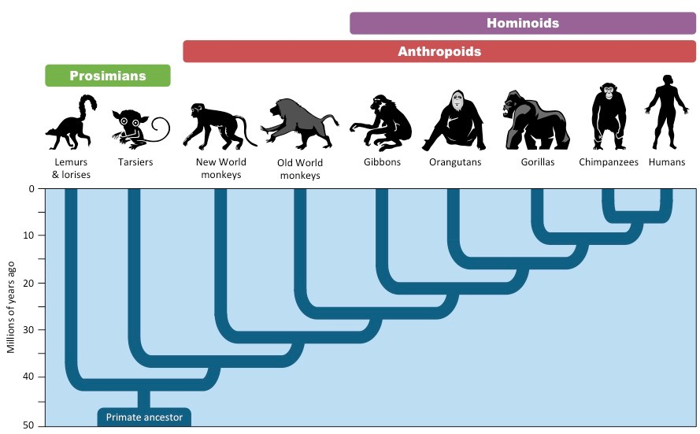

**Question 5**: Which primate species is most closely related to humans?

**Question 6:** Which primate species is most distantly related to humans?

**Question 7:** How long ago did speciation occur between tarsiers and the ancestor of all the anthropoids?

**Question 8:** According to this cladogram, about how long ago did the common ancestor between humans and chimpanzees exist?

**Question 9:** Explain why the statement “Humans evolved from monkeys” is incorrect.

# **Lab 11 Reflection**

**What concepts were most difficult in today’s lab activities?**

**What concepts were easiest to grasp?**

**What questions did today’s activities make you think of? What do you want to learn more about?**